Report: Optimising NYC Taxi Operations

Include your visualisations, analysis, results, insights, and outcomes. Explain your methodology and approach to the tasks. Add your conclusions to the sections.

## Data Preparation

* 1. Loading the dataset
     1. **Sample the data and combine the files**  
          
        There are 12 files which correspond to monthly data of 2023. There is close to 3M records in each file which corresponds to 36M rows if we consider 12 months of data. Loading this data and working on it may become computation challenge. So we select 5% of data from each day and hour so that we have fairly touched upon on all the data points across time. We use 3 for loops
        + Outer loop for each month.
        + Inner loop for day of month
        + Innermost loop for hour of day.
        + Then the data for hour, day and month is meged.

Day and Hour is derived from field “tpep_pickup_datetime” and month corresponds to each.

All the data is then written as a consolidated file, so that it is easier to load and analyse.

## Data Cleaning

### Fixing Columns

* + 1. **Fix the index**  
         
       After the data is prepared, the index is jumbled due 5% data is considered for day-hour. So we perform reset_index() with drop=True, which drops the index which is jumbled.
    2. **Combine the two airport_fee columns**

The columns Airport_fee and airport_fee might have been due to data entry error. We apply lambda function which works such that “If returns value of ‘Airport_fee’ when it is not null, else returns value of ‘airport_fee’. We keep the ‘Airport_fee’ and drop the redundant column ‘airport_fee’ once all the data is merged into Airport_fee.

### Handling Missing Values

* + 1. **Find the proportion of missing values in each column**

Missing values in column is found by isnull() function, which is looped across the dataframe for each column. The resultant Boolean mask is then acted upon by sum() function.

The proportion is calculated by Missing Values/Total rows.

* + 1. **Handling missing values in passenger_count**

There are about 64875 rows which are empty is passenger_count column. Since passenger_count is categorical variable we impute the values by mode of the coulumn. Further, there were 29683 rows where passenger_count is zero, where we imputed with mode. These can be data entry error by driver.

* + 1. **Handle missing values in RatecodeID**RatecodeID is a categorical variable, so we imputed the missing values with mode of the column. There were 64875 rows were value is imputed.
    2. **Impute NaN in congestion_surcharge**There were 64875 rows with Null value. Since it is general human behavior to leave the field blank when there is no surcharge. This might have creeped as Null values in dataset. So we impute the null values with 0.

### Handling Outliers and Standardising Values

* + 1. **Check outliers in payment type, trip distance and tip amount columns**
       - Removed rows where passenger_count is more than 6. There are only 22 rows but it may skew the data when we tend to calculate average passengers.
       - Dropped rows where trip_distance is zero and fare_amount is more than $300. This seems to be error is sensor for tracking distance.
       - Dropped rows where trip_distance is zero, but PULocationID and DOLocationID is different. This again suggests as sensor error or tracking failure.
       - Trips with more than 400miles are dropped as they will skew the data heavily and are very less %age of data.
       - Dropped rows where payment_type is zero, as it seems to be error in system, since there is no category as zero.
       - Dropped rows where fare_amount is more than $500, as it would heavily effect the statistical functions of the column and effect the analysis negatively. There are a total of 16 such rows.
       - There are 10K rows where wrong RatecodeID 99 is registered. Imputing them with mode of the column.

## Exploratory Data Analysis

### General EDA: Finding Patterns and Trends

* + 1. **Classify variables into categorical and numerical**Using the provided data dictionary the following are categorical and numerical variables

Categorical Columns - 'VendorID', 'tpep_pickup_datetime', 'tpep_dropoff_datetime', 'passenger_count', 'RatecodeID', 'store_and_fwd_flag', 'PULocationID', 'DOLocationID', 'payment_type'

Numerical Columns - 'trip_distance', 'fare_amount', 'extra', 'mta_tax', 'tip_amount', 'tolls_amount', 'improvement_surcharge', 'total_amount', 'congestion_surcharge', 'Airport_fee'

* + 1. **Analyse the distribution of taxi pickups by hours, days of the week, and months**Using data from ‘tpep_pickup_datetime’, columns pickup_hour, dropoff_hour, pickup_day, pickup_month are derived.

To extract these values various attributes of dt module is used like hour, day_name, strftime('%b') for month.

The data for trip_duration is derived by subtracting values of ‘tpep_dropoff_datetime’ and ‘tpep_pickup_datetime’ and then dividing by 60. The data captured is in minutes.

Following are the visualizations of the categorical variables

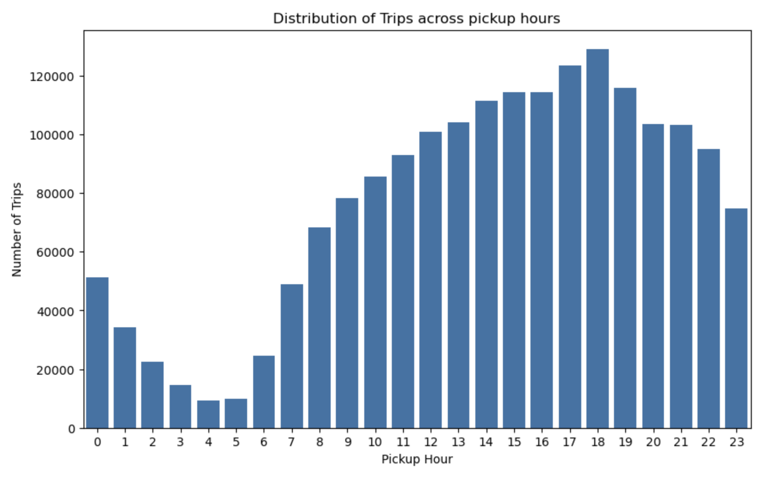

Analysis of Number of Trips across different times of day

* The peak hours for Taxis is between 3pm - 7pm.
* The slump hours are between 3am - 5am
* Heavy spike is seen between 6am - 9am. There after there is a gradual increase in taxi demand.
* After spiking at 6pm, there is a gradual decrease, however the maximum amount of decrease is we see between 11pm - 3am

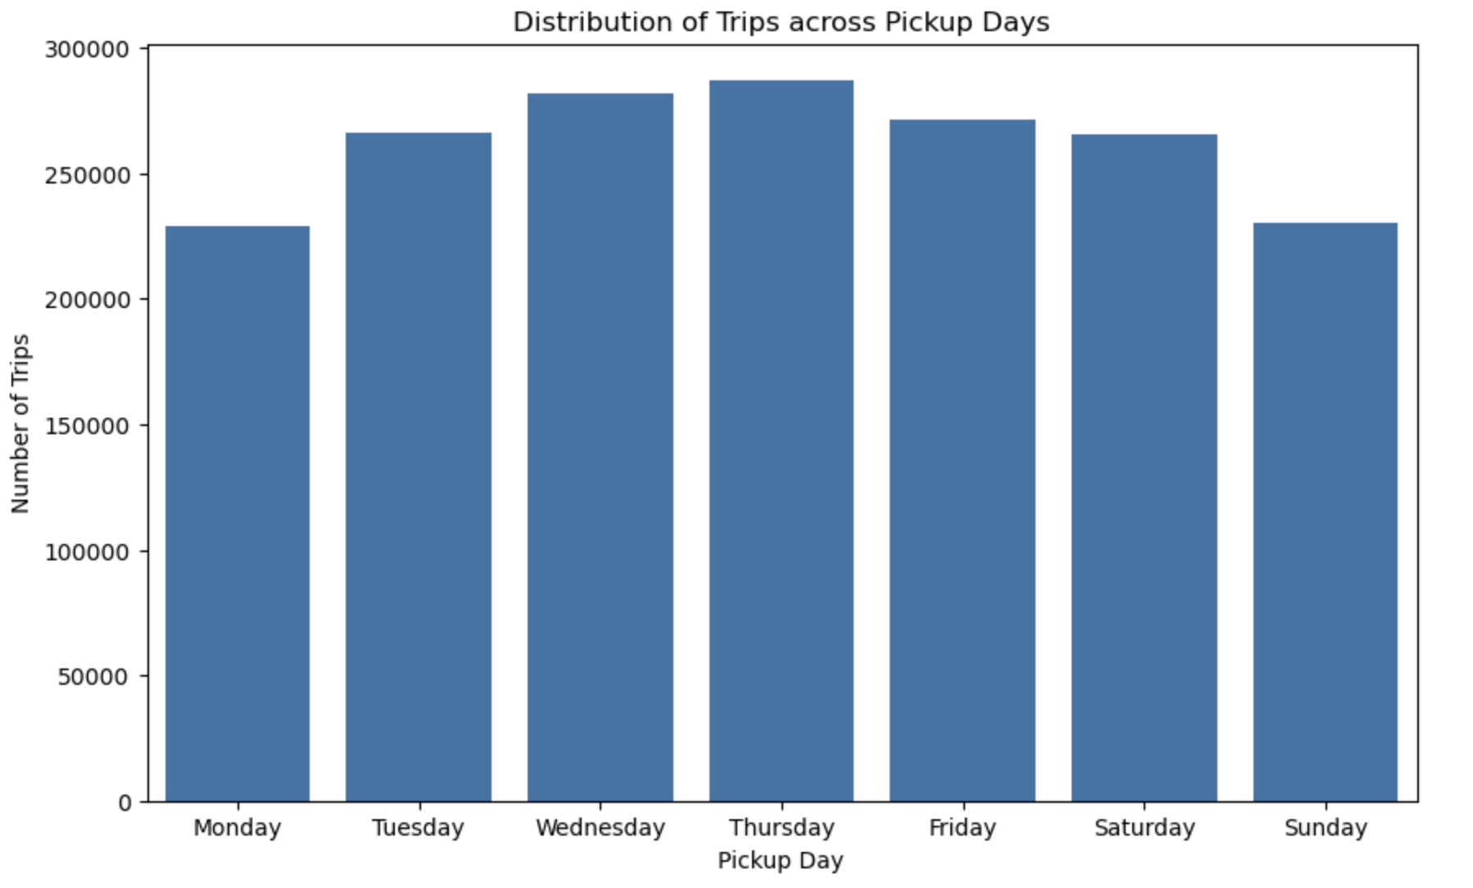

Analysis of Number of Trips across different days of week

* There is a gradual increase from Monday to Thursday and the there is a decline in demand.
* Wednesday and Thursday have highest number of trips during the weekday.
* Even though Saturday is a weekend but still we see demand is comparable with weekdays, most probably due to people going out after busy week.

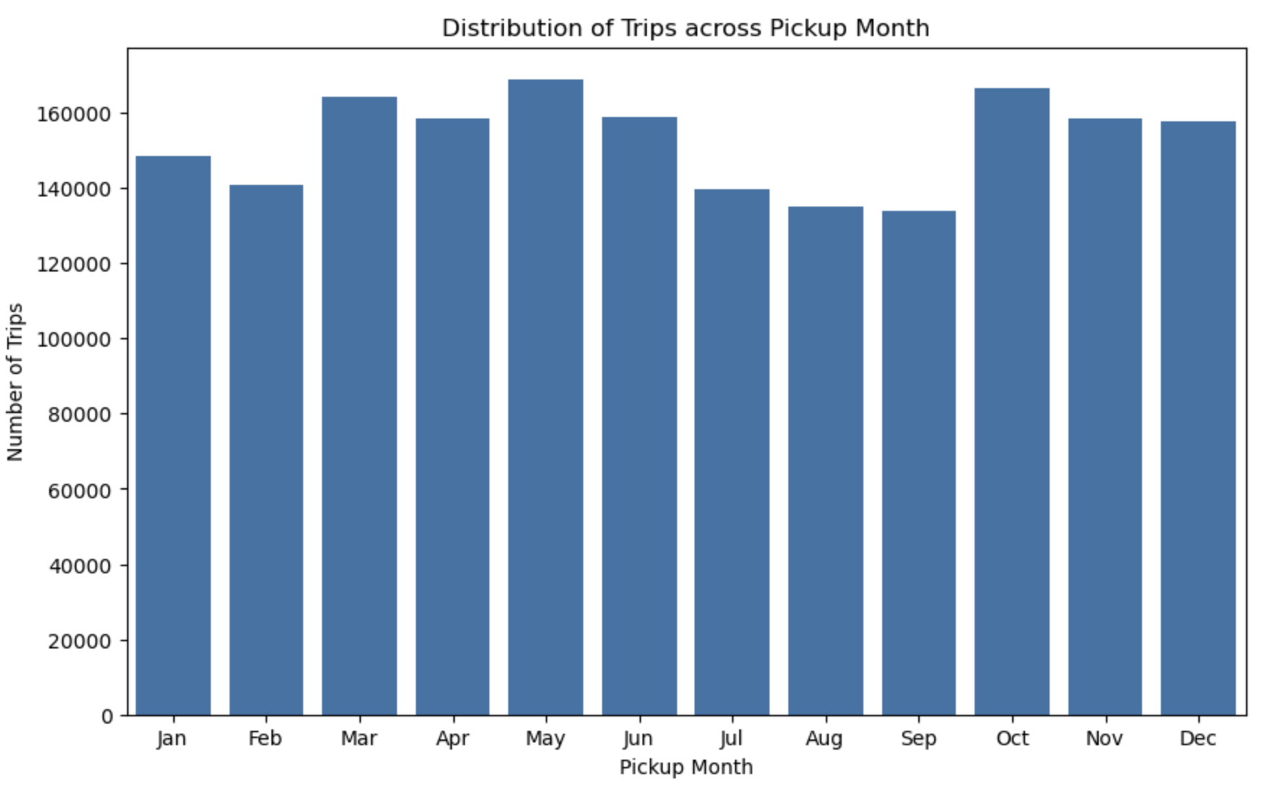

Analysis of Number of Trips across Months

* There is a spike in demand during the months March, April, May. This is spring and a tourist season.
* There is a slump in July, August and September
* There is a sudden spike in demand for the month of October. During the Fall, there is a influx of tourist.

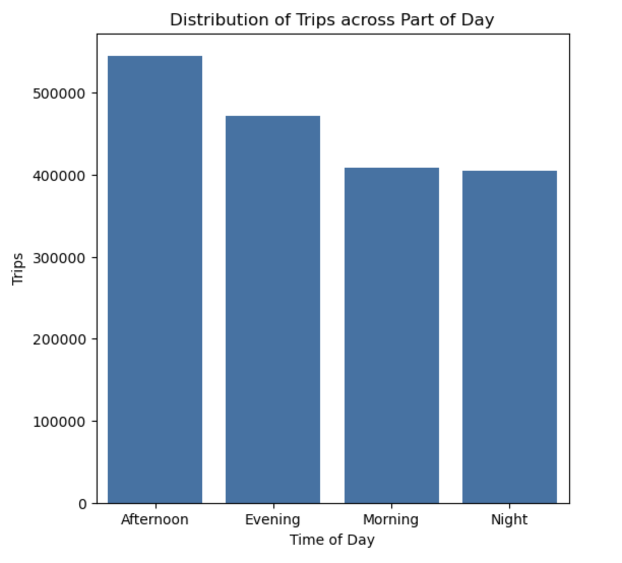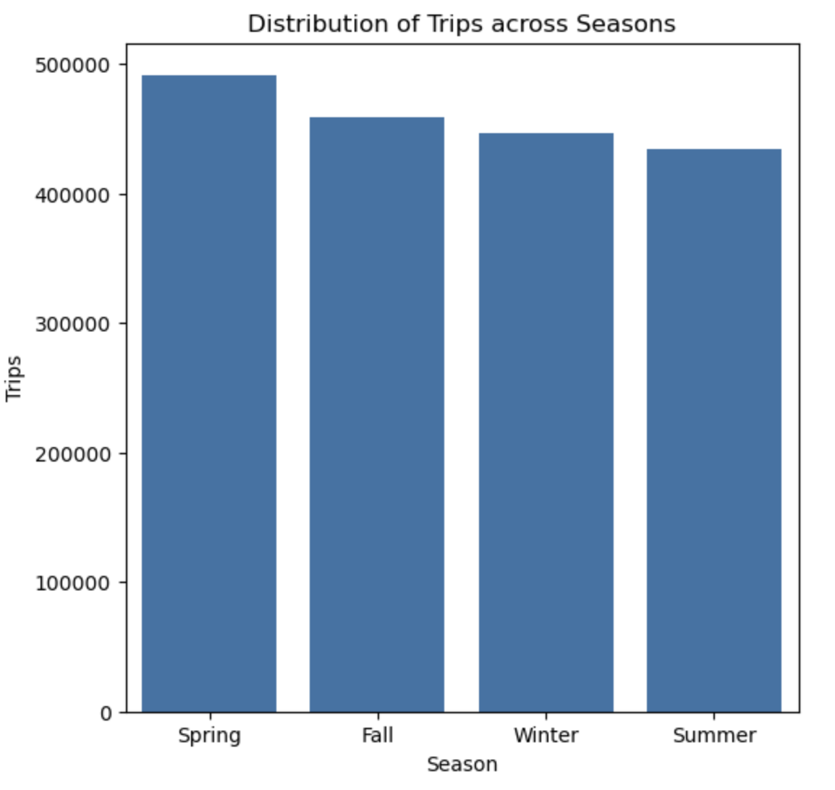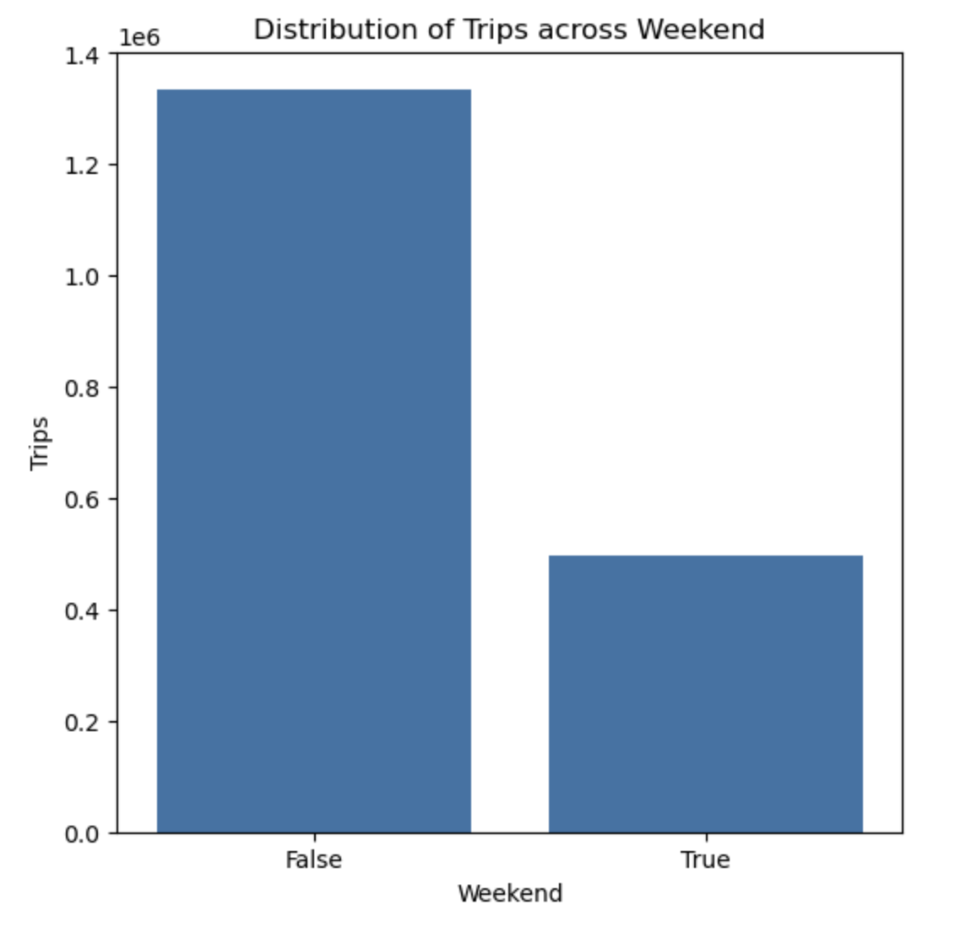

Analysis of Number of Trips across Time of Day, Season, Weekend

* During the Spring there is a increase in demand. due to people tend to move out after the winter season
* The demand during Fall, Winter and Summer is comparable.
* There is heavy demand during Afternoon hours
* Demand during Morning and Night hours is comparable
* There is a huge difference in demand during weekdays vs weekends.
* The Demand is more than double on weekdays.
  + 1. **Filter out the zero/negative values in fares, distance and tips**The zero/negative values of fare and distance does not make sense and seems to be error in data entry by fleet drivers.   
       1. Dropped the rows which have fare amount as zero.   
       2. Dropped rows where trip distance is zero and Pickup/Drop distance is different.  
       3. Removed rows where total amount is zero/negative.  
       4. Removed rows where trip duration is zero.   
         
       Tip amount can be zero in cases where customer preferred not to pay any Tips. So not dropping them.
    2. **Analyse the monthly revenue trends**

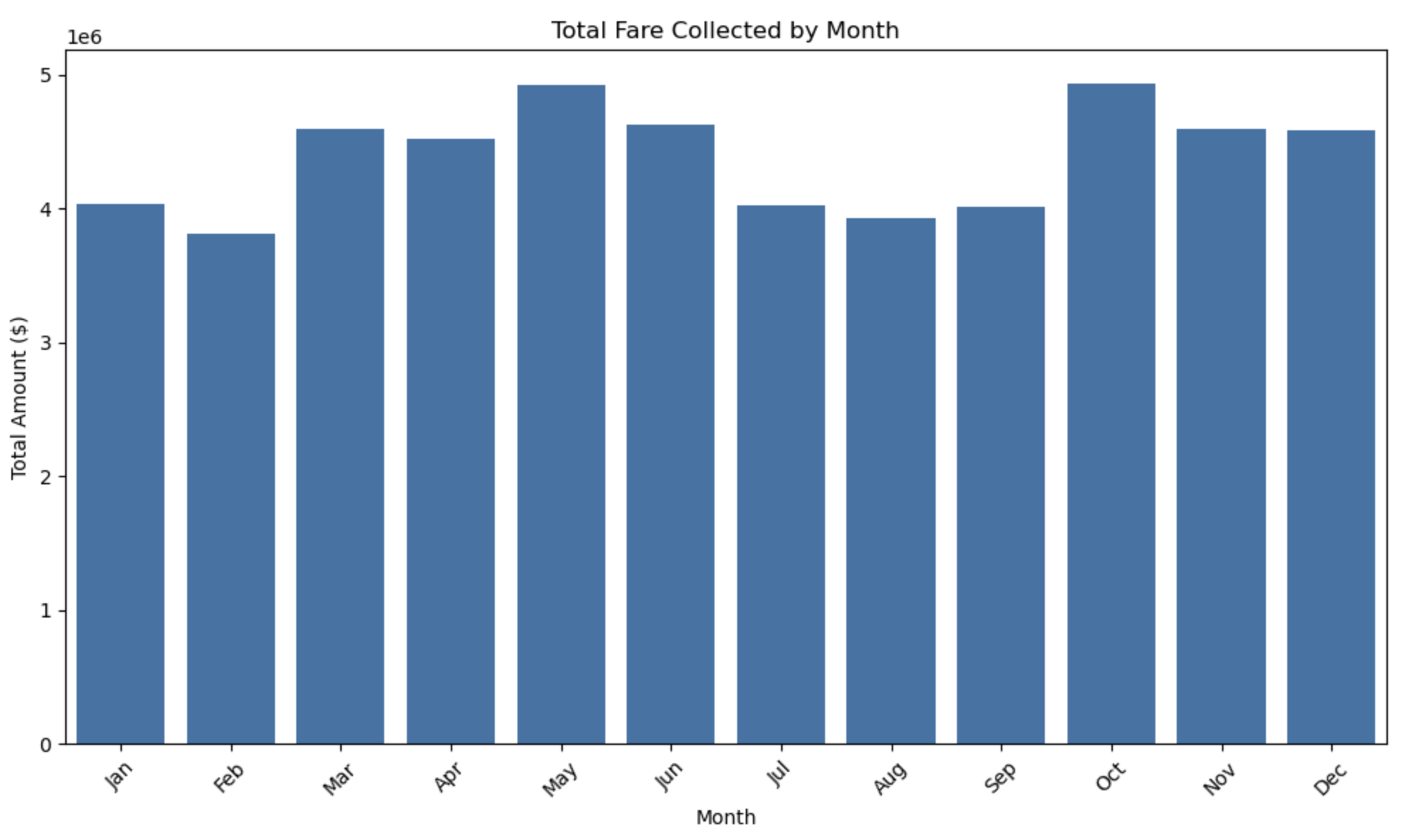Analysis of Total Amount across Months

* The revenue collected during the months of May and October are highest. Amount is just under $5M
* Lowest revenue is generated in month of Feb. Amount generated is less than $4M.
* Amount generated during remaining months vary between ~$4.5M - ~$4.7M
* These months Mar, Apr, Jun, Jul, Aug, Sep can be considered for scaleup to reduce the gap in revenue.
  + 1. **Find the proportion of each quarter’s revenue in the yearly revenue**Proportion for Quarterly amount for 2023

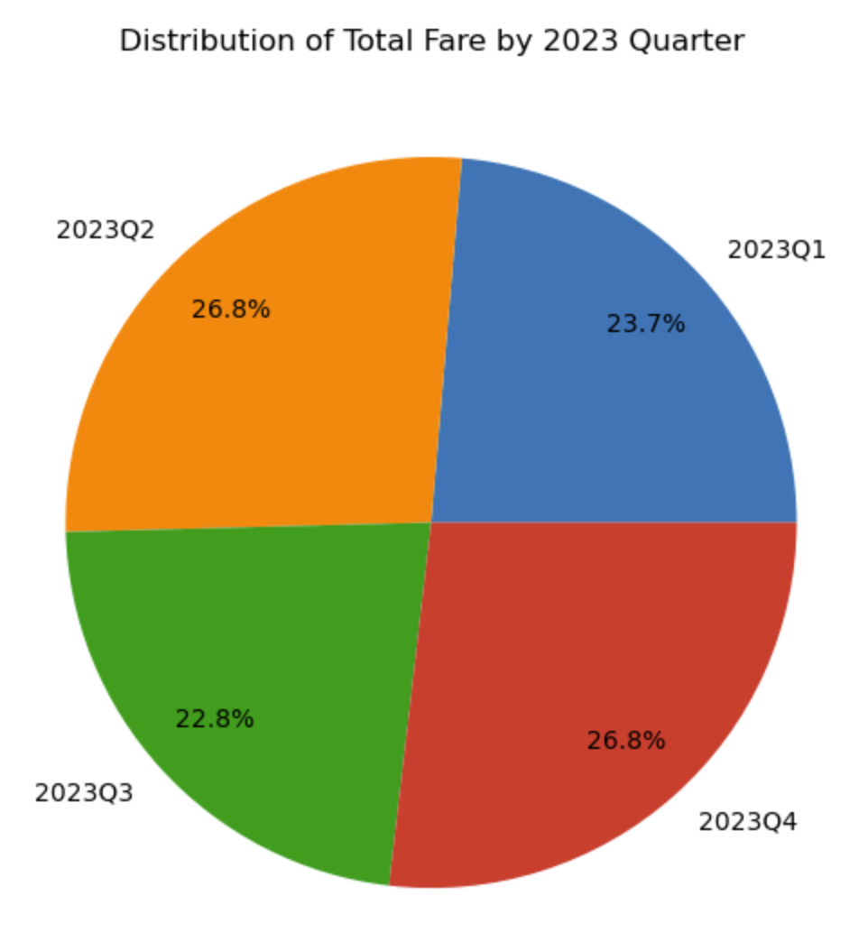

|  | **quarter** | **total_amount** | **proportion_percent** |
| --- | --- | --- | --- |
| 0 | 2023Q1 | 12440894.25 | 23.66 |
| 1 | 2023Q2 | 14069160.28 | 26.75 |
| 2 | 2023Q3 | 11962254.18 | 22.75 |
| 3 | 2023Q4 | 14113571.87 | 26.84 |

* + 1. **Analyse and visualise the relationship between distance and fare amount**

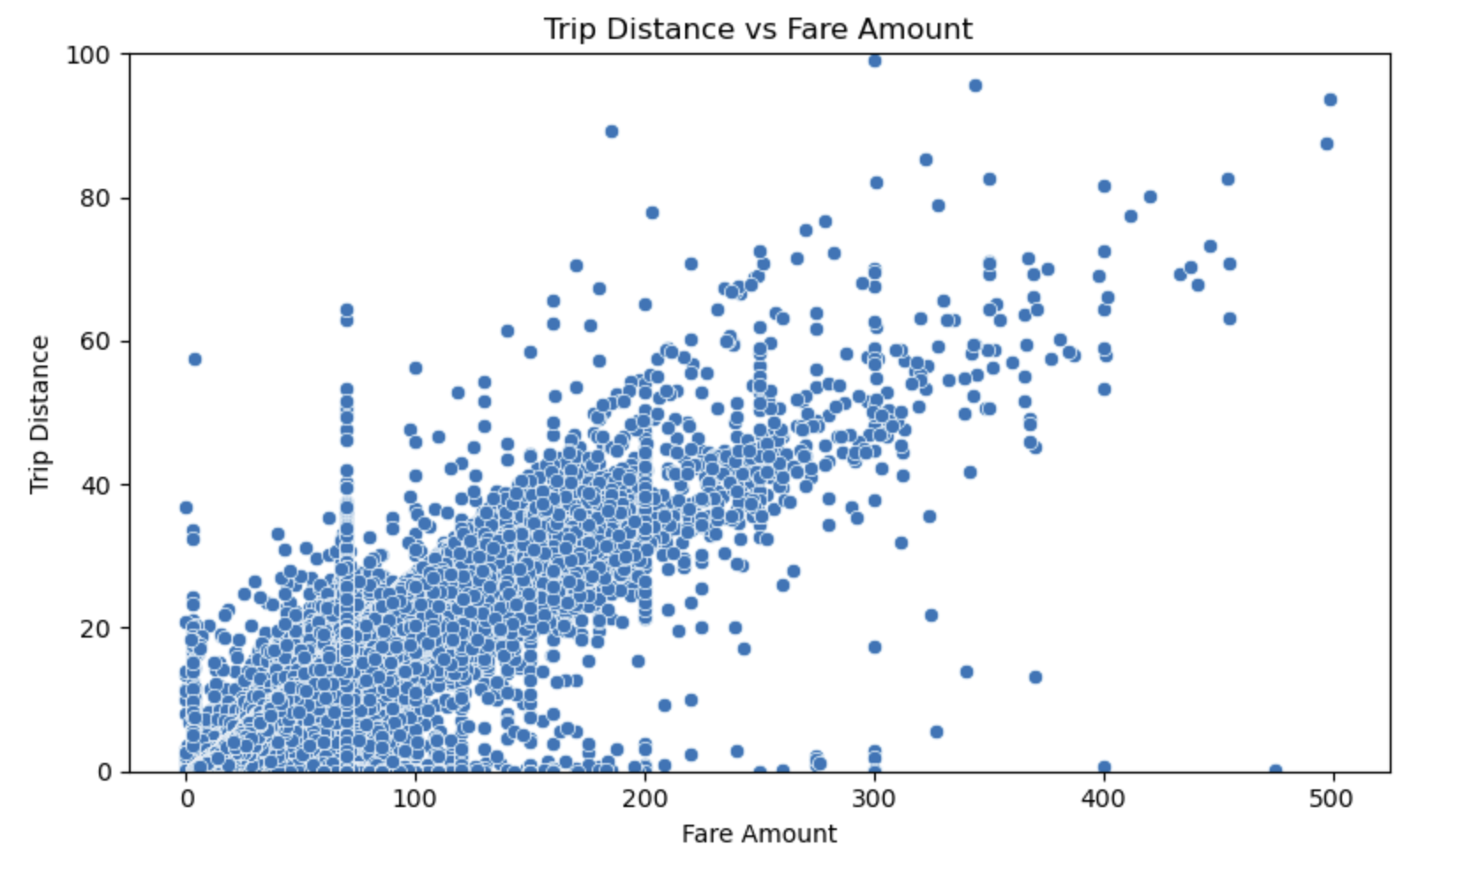

Analysis of Fare Amount vs Trip Distance

* There is strong positive correlation between Fare Amount and Trip Distance
* Between 0 - 30 miles there is high variance in fare amount. This suggests some short rides are charged higher.
* There can be congestion issues due to which trips is less distance are charged more.
  + 1. **Analyse the relationship between fare/tips and trips/passengers**

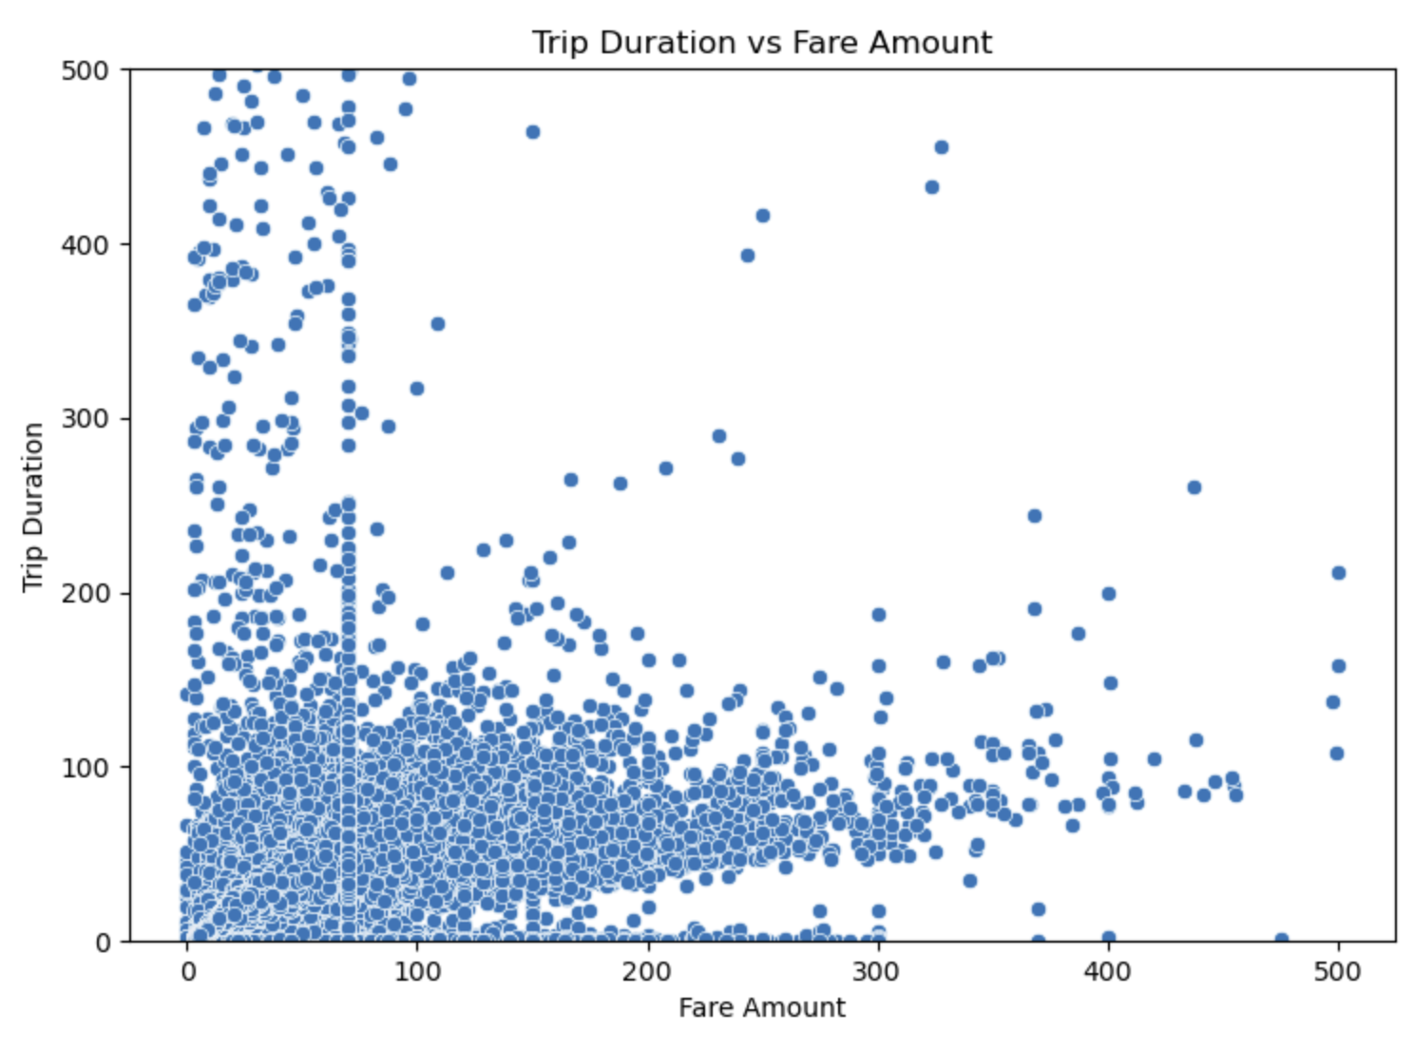

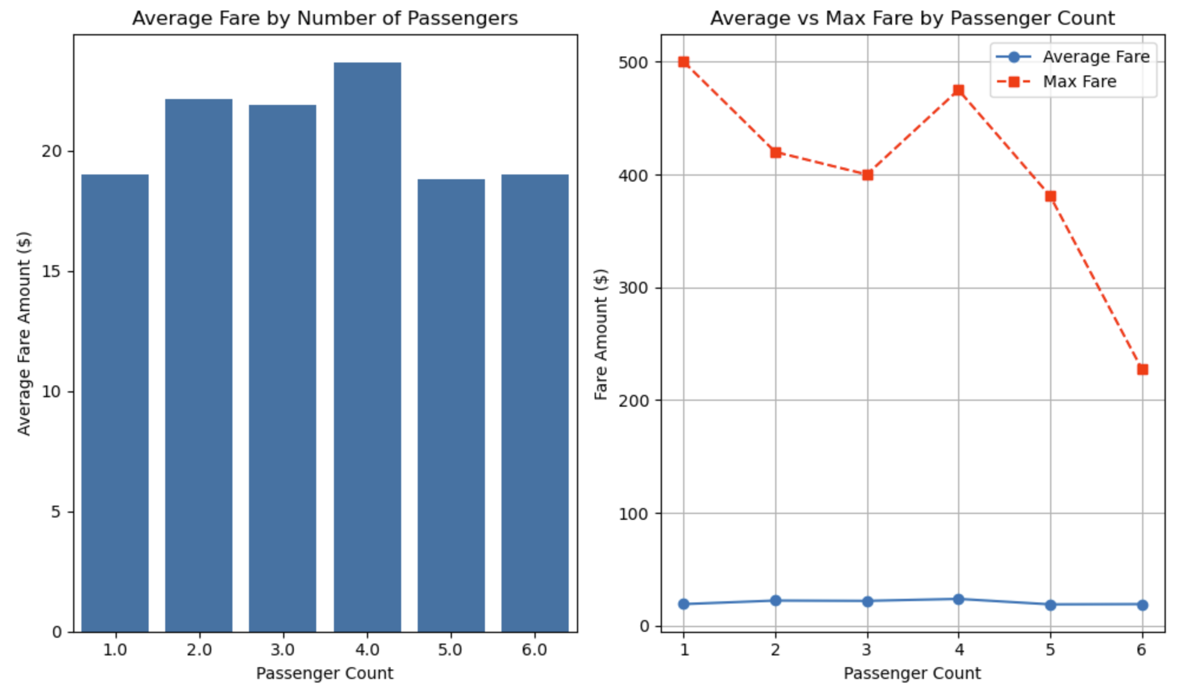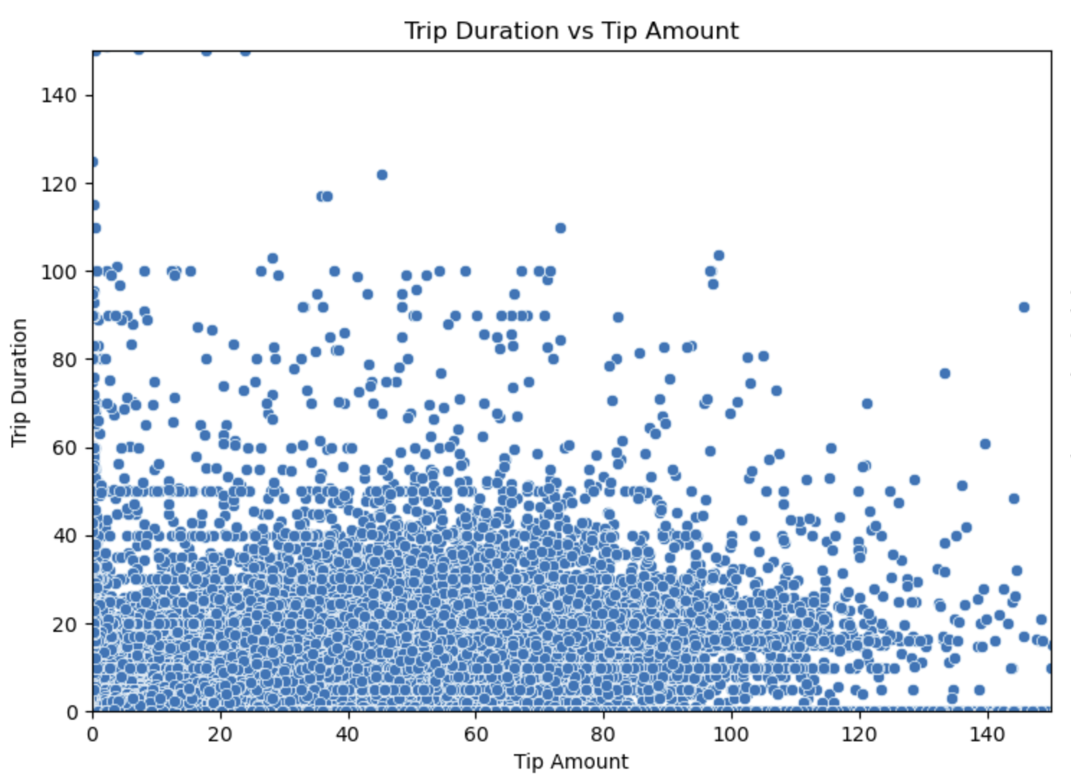 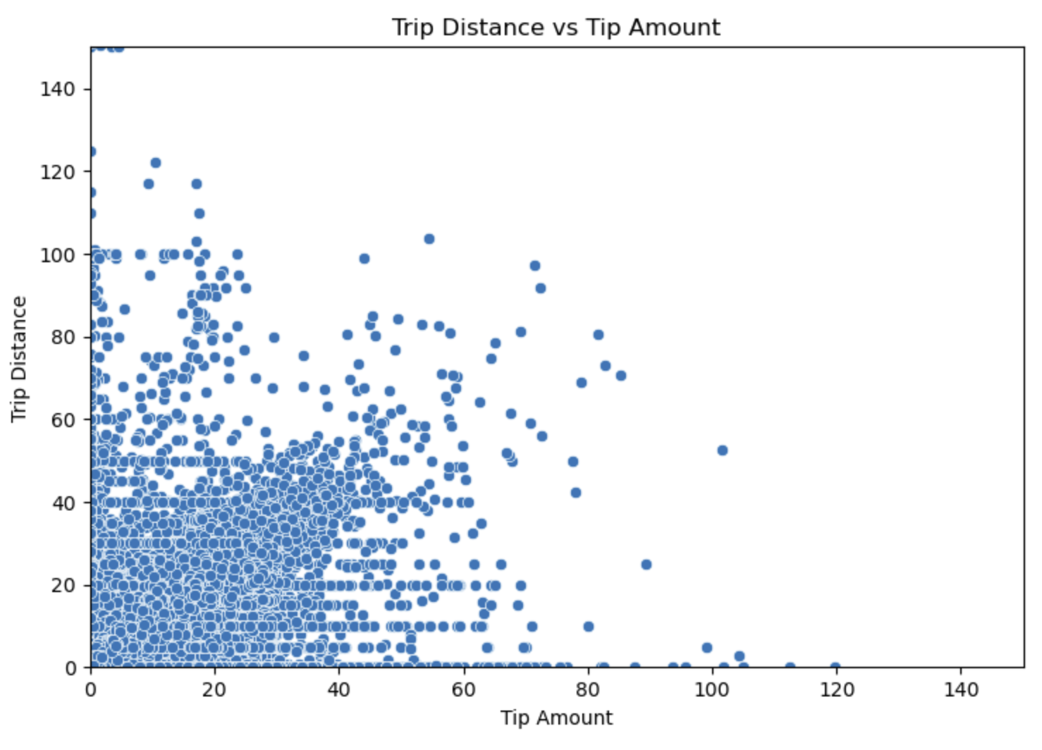

Analysis

1. The average fare for solo travellers is quite high.
2. There is a spike in average fare for passenger count 4 and 2 indicating that family and couple travellers tend to have costlier trips.
3. There is shar decline in max fares when passenger count is 5 and 6.
4. Average fare remains fairly stable across all groups (ranging $18–$23), with only minor variance.
5. The max fare amount is high in passnger count 1 which might push the average amount to higher side.
6. Graph for median shows similar trend as average but the variance is reduced further.
7. The average fare for solo travellers is quite high.
8. There is a spike in average fare for passenger count 4 and 2 indicating that family and couple travellers tend to have costlier trips.
9. There is shar decline in max fares when passenger count is 5 and 6.
10. Average fare remains fairly stable across all groups (ranging $18–$23), with only minor variance.
11. The max fare amount is high in passnger count 1 which might push the average amount to higher side.
12. Graph for median shows similar trend as average but the variance is reduced further.
13. From correlation matrix we can see there is a moderate positive correlation between these two variables.
14. Low fare(<$100) trips are taking longer duration. This may be due to congestion, idle time, slow driving.
15. Higher fare (> $200) trips take shorter durations, this probably most of the rides are in freeways or interstate.
16. There are high number of outliers in all the bins, there it increases variance in the data.
    * 1. **Analyse the distribution of different payment types**Distribution of various payment types

|  |  |
| --- | --- |
| Payment Type | Trips |
| Credit Card | 1486230 |
| Cash | 314694 |
| No Charge | 13380 |
| Dispute | 8701 |

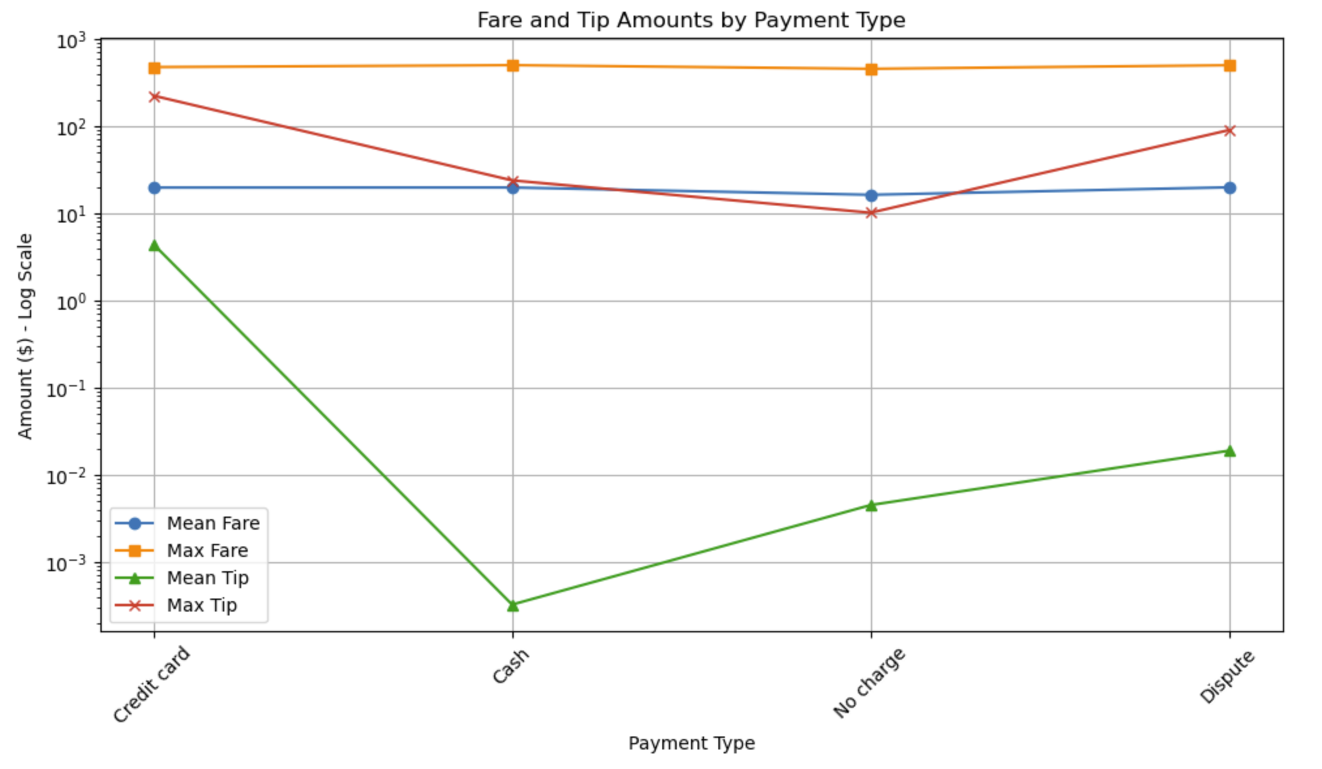

Analysis of Payment method

1. Most of the payments are made via credit cards.
2. The max and mean amount for credit card, cash and disputed is almost same.
3. Average tip amount is way high in case of credit card.
4. Tip amount is higher in disputed transactions, which may suggest that customers disputing the transactions when higher tip is registered. This may be cases where customer might have paid and then realized the tip amount is high.
5. Mean tip amount is very less in cash, suggesting data might not have been recorded.
   * 1. **Load the taxi zones shapefile and display it**The library of geopandas is used to read the shape file and plot it.

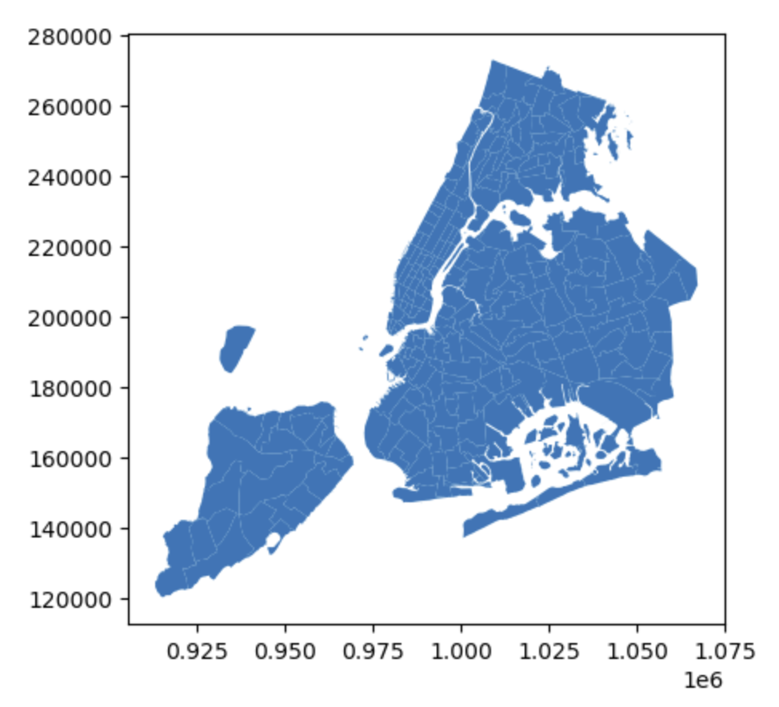

* + 1. **Merge the zone data with trips data**For merging zones dataframe only relevant columns like zone, LocationID and borough are considered.  
       Dataframe is merged using left join on PUlocationID and LocationID
    2. **Find the number of trips for each zone/location ID**value_counts() on LocationID column of merged dataframe will provide the relevant information.  
         
       Following is Top 50 pickup zones as per trip count.  
       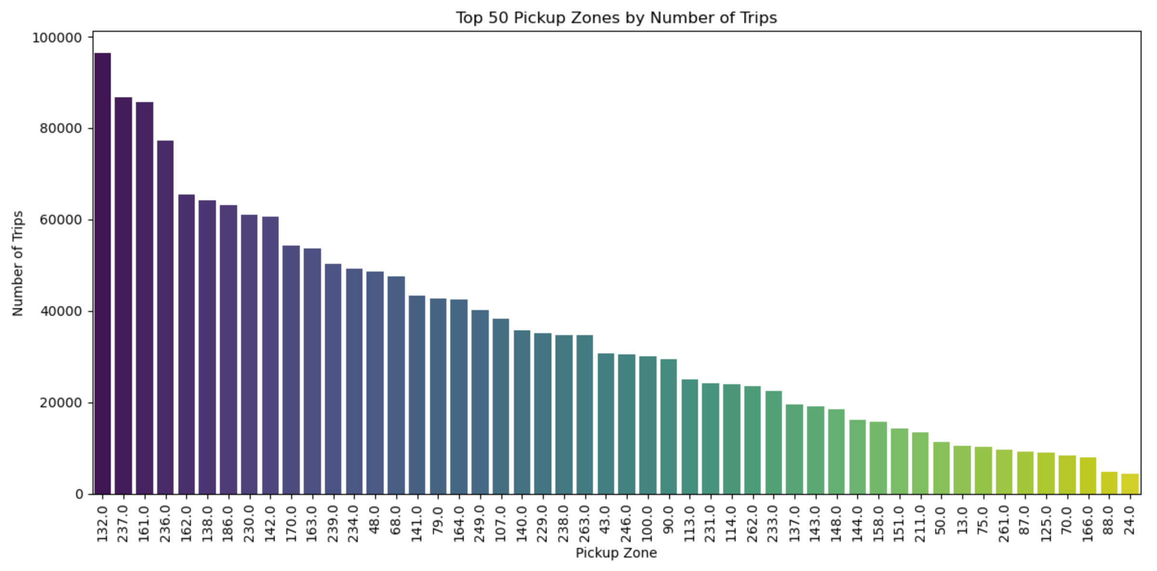
    3. **Add the number of trips for each zone to the zones dataframe**Merged the zones dataframe with trip_count dataframe using Left join. The merge is done on the basis of LocationID column which is common on both the dataframes.
    4. **Plot a map of the zones showing number of trips  
       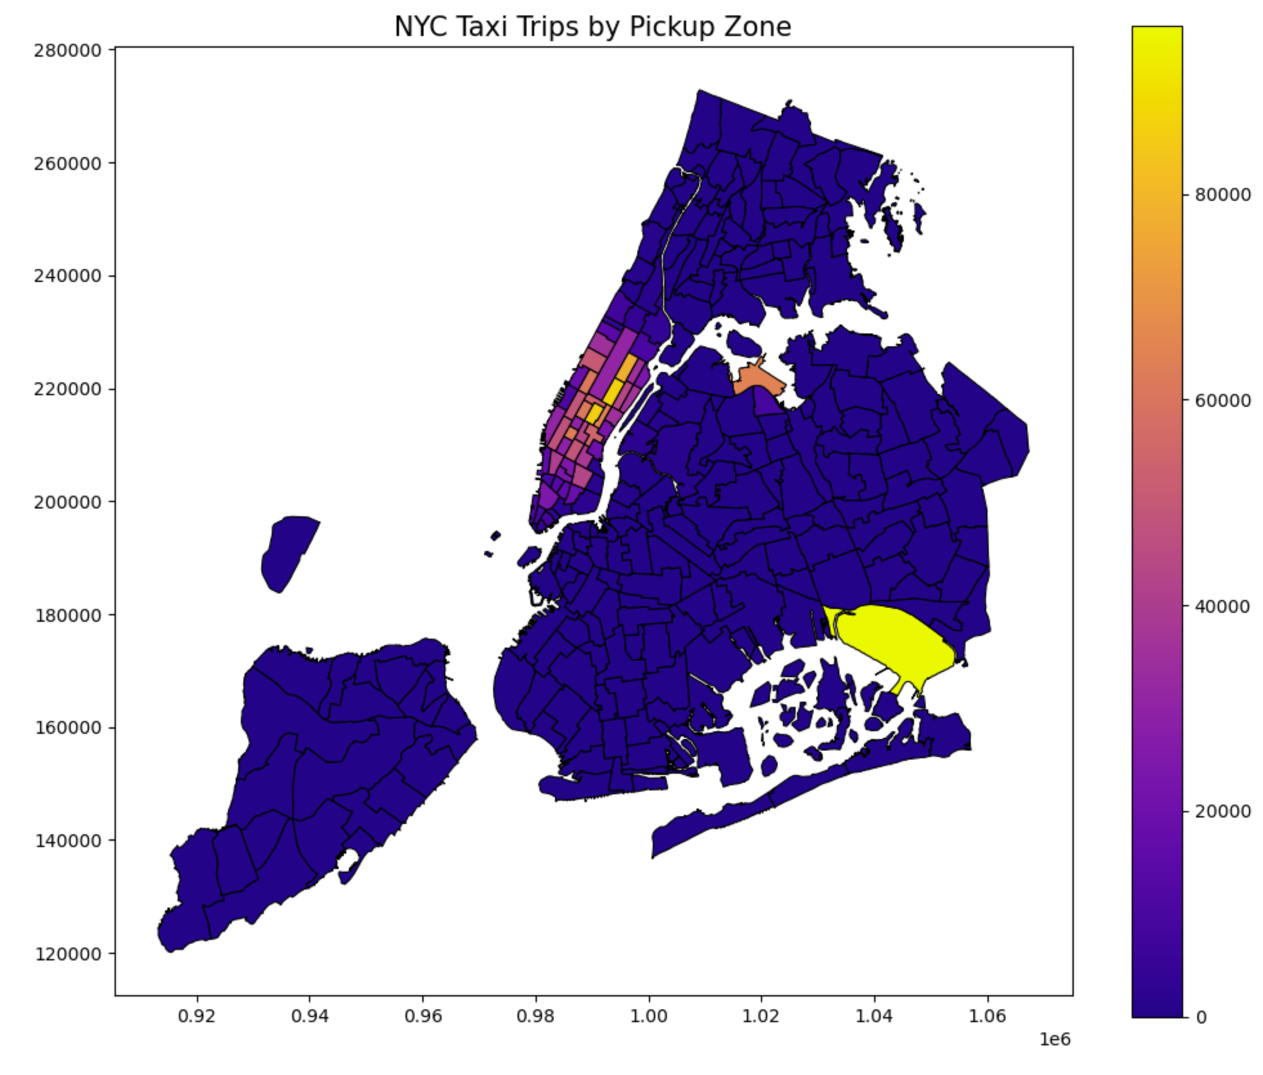**The column trip_count is used to color code the map showing trip density.

Analysis on Zones

* In zones, the JFK Airport contributes maximum amount of Trips close to 96K.
* Interestingly, Manhattan tops the lists with number of trips close to 1.6M which is about 9 times than Queens.

* + 1. **Conclude with results**

Busiest hours, days and months

1. Peak demand occurs during 3 PM to 7 PM, with a secondary spike from 6 AM to 9 AM.

2. Weekday demand increases from Monday to Thursday, with Wednesday and Thursday being the busiest.

3. Saturday remains strong in demand, suggesting leisure travel.

4. Spring months (March–May) see the highest demand, especially in May.

5. Slump periods: February and summer months (July–September).

Revenue Trend

1. May and October generate the highest revenue (~$5M).

2. February generates the least (<$4M).

3. Q2 (Apr–Jun) and Q4 (Oct–Dec) are the highest revenue quarters, aligning with tourist seasons.

4. Q1 and Q3 lag slightly behind, though Q1 (22.8%) and Q3 (23.7%) are very close.

Fare Vs trip distance, trip duration and passenger counts

1. Strong positive correlation — longer trips have higher fare.

2. For trips up to 30 miles, there's high variance, indicating short rides can be expensive

3. Solo travellers (1 passenger) show highest average fare, possibly skewed by outliers.

4. Couples and small groups (2-4) also show slightly higher fares.

5. Median fare is fairly stable (~$18–$23) across all passenger groups.

Tip amount and Trip distance

1. Most of Tip is concentrated within 40 miles / $40.

2. Median tip increases gradually up to 30–40 mins, then fluctuates.

3. Trip distance appears to be more influential in predicting tip amount.

Payment Method Analysis

1. Credit cards are the dominant payment mode.

2. Average tip amount is highest in credit card transactions.

3. Disputed transactions show high tips, possibly due to post-transaction realization by the customer.

4. Cash payments show very low tip amounts, potentially due to unrecorded data.

Busiest zones

1. Certain zones like “207 → 207”, “216 → 216”, “144 → 100”, and “113 → 244” appear repeatedly among the slowest routes.

2. These indicate congested corridors or high-traffic zones.

* 1. **Detailed EDA: Insights and Strategies**
     1. **Identify slow routes by comparing average speeds on different routes**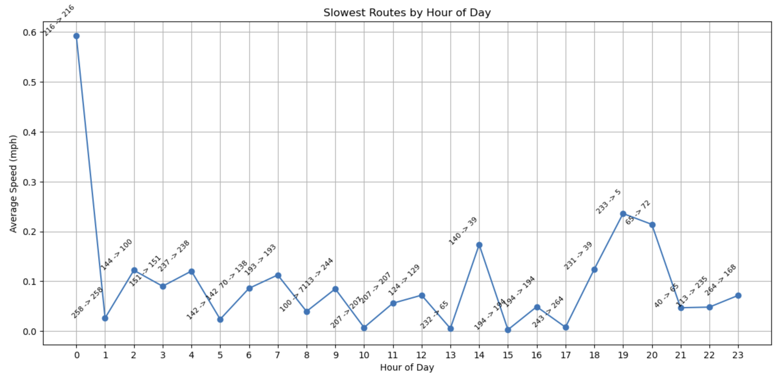

List of zones which have lowest average speed –

'Upper East Side South', 'Saint Michaels Cemetery/Woodside','Lincoln Square East', 'Manhattan Valley', 'Queensbridge/Ravenswood', 'Garment District', 'Little Italy/NoLiTa', 'Woodhaven', 'East Elmhurst', 'Two Bridges/Seward Park', 'Greenwich Village North', 'South Ozone Park', 'Carroll Gardens', 'Lenox Hill East', 'TriBeCa/Civic Center', 'Downtown Brooklyn/MetroTech', 'Howard Beach', 'Randalls Island', 'UN/Turtle Bay South', 'Washington Heights North'

* + 1. **Calculate the hourly number of trips and identify the busy hours  
       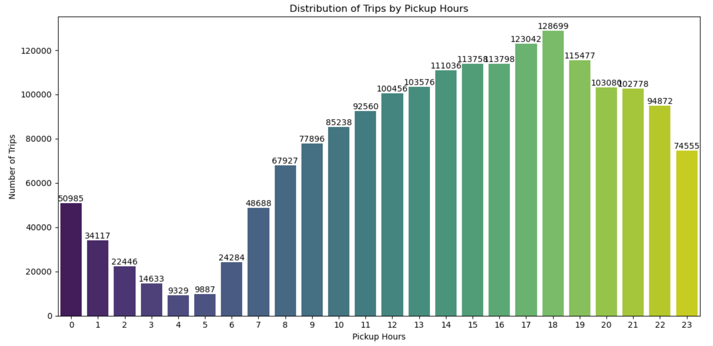**The Busiest hour is 18 with Number of Trips 128699
    2. **Scale up the number of trips from above to find the actual number of trips**Since sample fraction is 0.05, so the scale_factor = 1/(sample fraction) = 20
    3. **Compare hourly traffic on weekdays and weekends**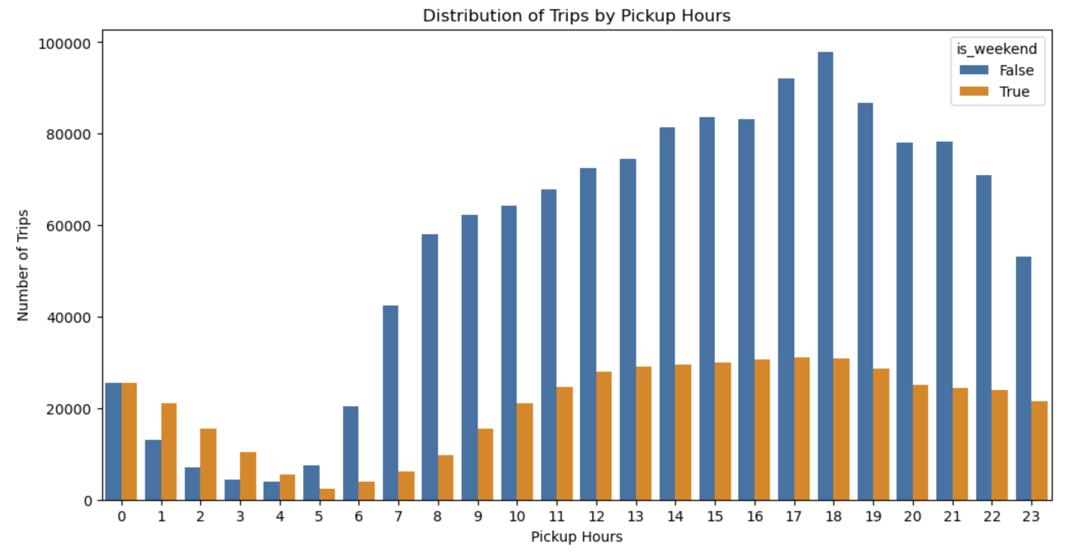

Following are the inferences

1. Busiest hours for Taxis is between 4pm to 7pm, with demand peaking at 6pm.

2. Lean hours are 2am to 5am

3. Demand in higher on weekends for late night hours (12 am - 4am)

4. During the day we see weekdays have consistently higher demand.

5. There is heavy spike for hours 6am to 8am.

|  | **DOLocationID** | **dropoff_count** |
| --- | --- | --- |
| 0 | 236 | 81028 |
| 1 | 237 | 77419 |
| 2 | 161 | 71329 |
| 3 | 230 | 56257 |
| 4 | 170 | 54157 |
| 5 | 162 | 52106 |
| 6 | 142 | 51318 |
| 7 | 239 | 51116 |
| 8 | 141 | 48399 |
| 9 | 68 | 46188 |

* + 1. **Identify the top 10 zones with high hourly pickups and drops**

|  | **PULocationID** | **pickup_count** |
| --- | --- | --- |
| 0 | 132 | 96381 |
| 1 | 237 | 86659 |
| 2 | 161 | 85684 |
| 3 | 236 | 77274 |
| 4 | 162 | 65499 |
| 5 | 138 | 64131 |
| 6 | 186 | 63176 |
| 7 | 230 | 60989 |
| 8 | 142 | 60723 |
| 9 | 170 | 54325 |

* + 1. **Find the ratio of pickups and dropoffs in each zone**Top 10 zones with high Pickup/Drop ratio

|  | **zone** | **pickup_drop_ratio** |
| --- | --- | --- |
| 0 | East Elmhurst | 8.657620 |
| 1 | JFK Airport | 4.615727 |
| 2 | LaGuardia Airport | 2.890998 |
| 3 | Penn Station/Madison Sq West | 1.576720 |
| 4 | Central Park | 1.375163 |
| 5 | Greenwich Village South | 1.374636 |
| 6 | West Village | 1.325880 |
| 7 | Midtown East | 1.257034 |
| 8 | Midtown Center | 1.201251 |
| 9 | Garment District | 1.190621 |

* + 1. **Identify the top zones with high traffic during night hours**

Top 10 Zones for Night hours (11pm - 5AM)

Pickup Zones -

['East Village' 'JFK Airport' 'West Village' 'Clinton East'

'Lower East Side' 'Greenwich Village South' 'Times Sq/Theatre District'

'Penn Station/Madison Sq West' 'Midtown South' 'East Chelsea']

Dropoff Zones -

['East Village' 'Clinton East' 'Murray Hill' 'East Chelsea' 'Gramercy'

'Lenox Hill West' 'Yorkville West' 'West Village'

'Times Sq/Theatre District' 'Upper West Side South']

* + 1. **Find the revenue share for nighttime and daytime hours**

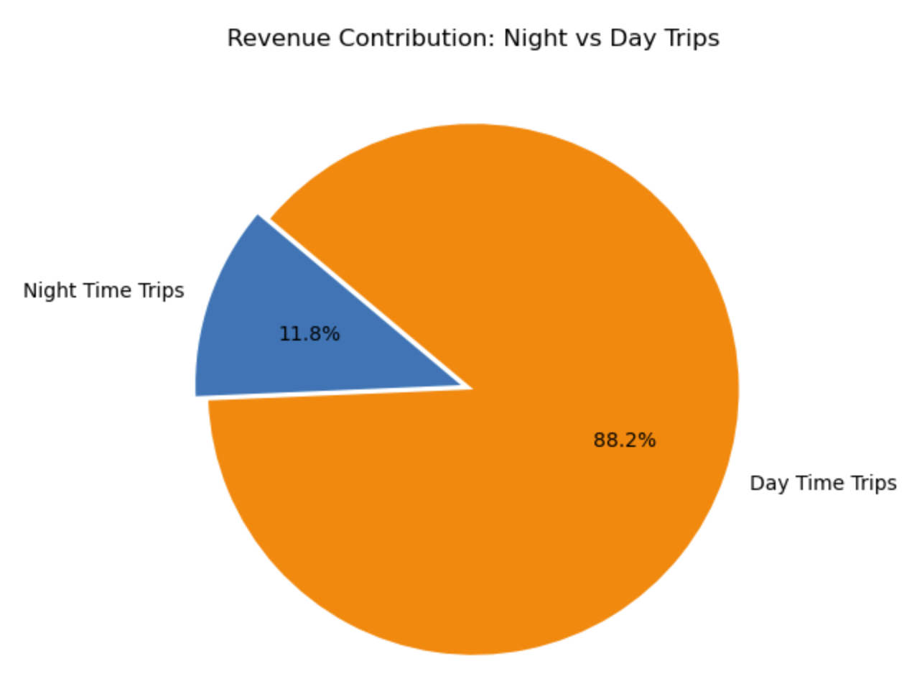

* + 1. **For the different passenger counts, find the average fare per mile per passenger**

|  | **passenger_count** | **avg_fare_per_mile_per_passenger** |
| --- | --- | --- |
| 0 | 1.0 | 10.850902 |
| 1 | 2.0 | 6.467983 |
| 2 | 3.0 | 3.942366 |
| 3 | 4.0 | 4.380333 |
| 4 | 5.0 | 1.709852 |
| 5 | 6.0 | 1.351391 |

* + 1. **Find the average fare per mile by hours of the day and by days of the week**

|  | **pickup_day** | **avg_fare_per_mile** |
| --- | --- | --- |
| 0 | Sunday | 12.679804 |
| 1 | Tuesday | 11.348938 |
| 2 | Thursday | 11.209851 |
| 3 | Wednesday | 11.072212 |
| 4 | Saturday | 10.988632 |
| 5 | Monday | 10.963886 |
| 6 | Friday | 10.928707 |

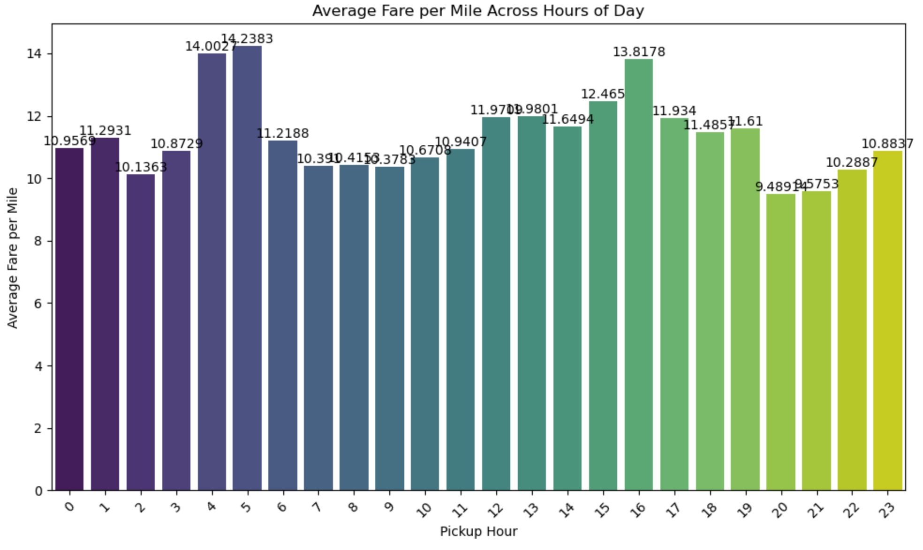

* + 1. **Analyse the average fare per mile for the different vendors  
         
       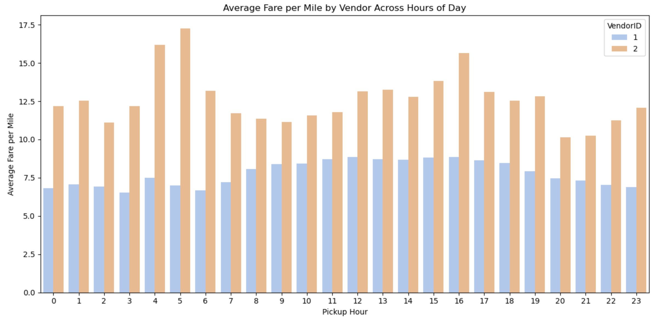**

Analysis of Average fare per Mile vs Pickup Hour and VendorID

1. The overall values are always higher for vendorid 2 (VeriFone Inc.).

2. The difference is higher for the early morning hrs 4am and 5am.

* + 1. **Compare the fare rates of different vendors in a distance-tiered fashion**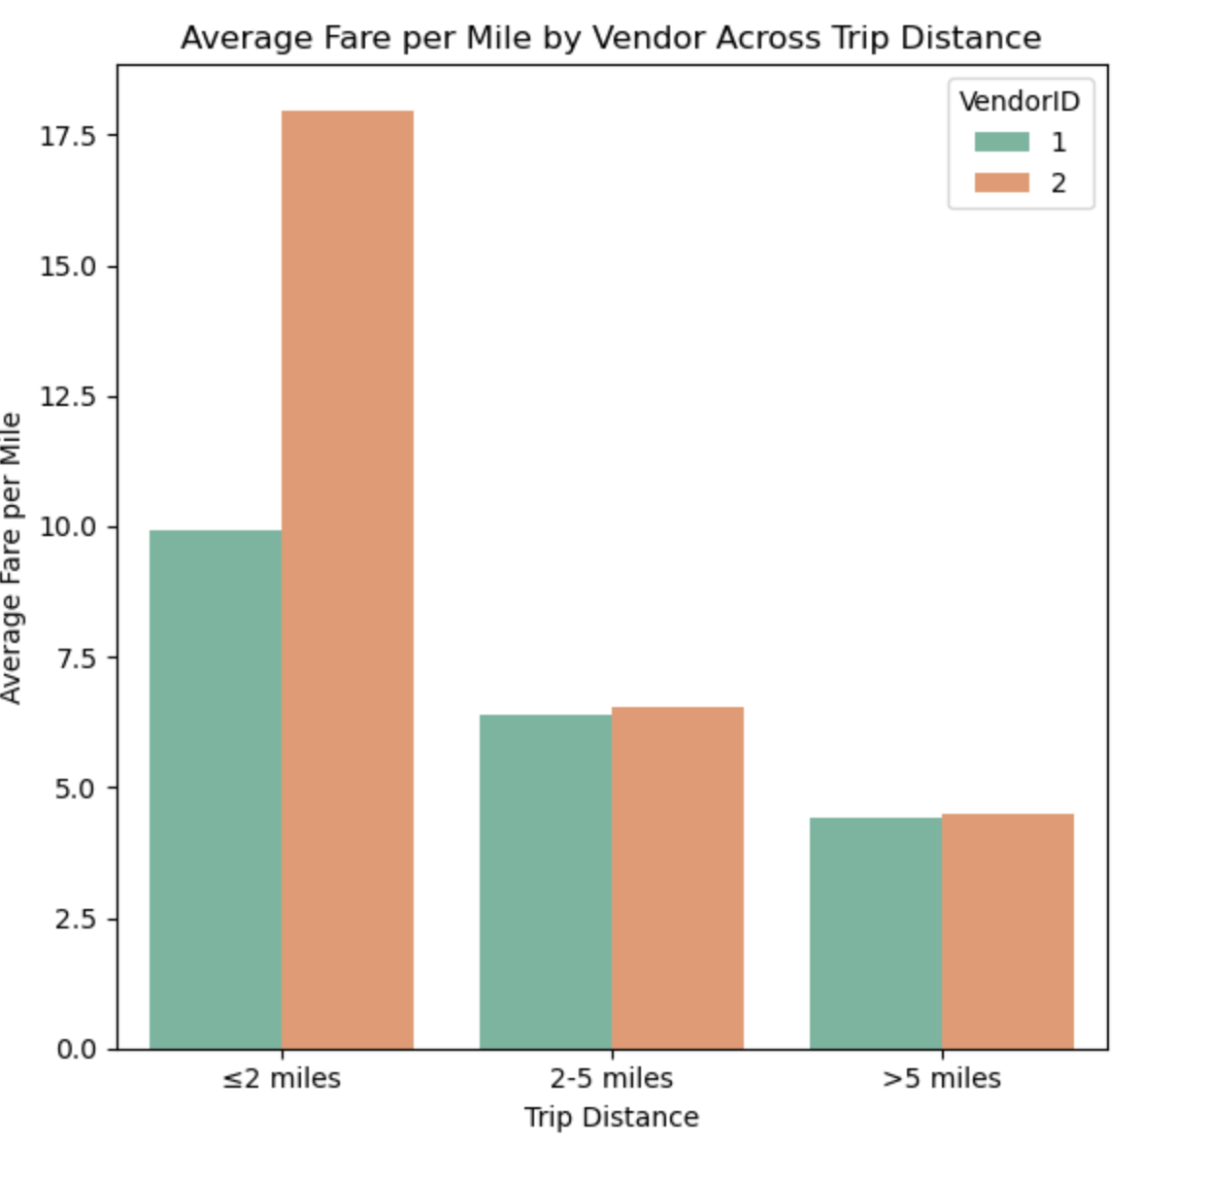

Analyse Average fare per mile across Trip Distance

1. The Vendor 2(VeriFone Inc.) have a very high Average fare per mile when trip distancesare less than 2 miles.

2. Both Vendors have comparable values for the metric on medium and far trip distances.

* + 1. **Analyse the tip percentages**

|  | **passenger_count** | **tip_percent** |
| --- | --- | --- |
| 0 | 1.0 | 20.936331 |
| 1 | 2.0 | 19.728015 |
| 2 | 3.0 | 19.040020 |
| 3 | 4.0 | 17.440428 |
| 4 | 5.0 | 20.516059 |
| 5 | 6.0 | 20.644005 |

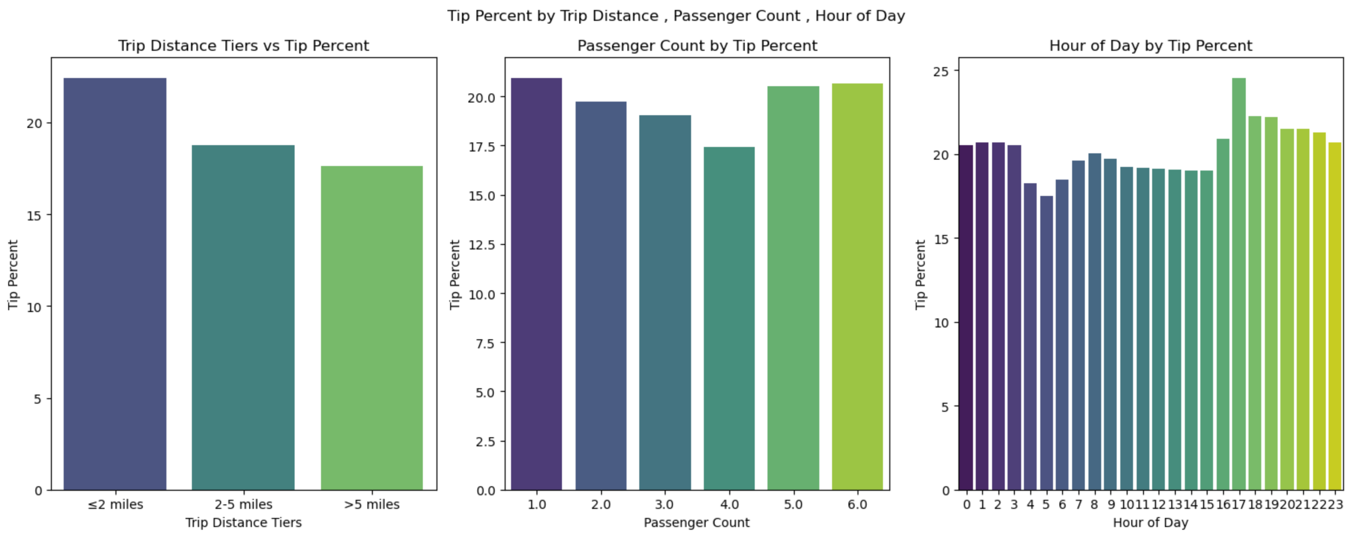

Analysis on Tip Amount

1. On smaller trips Tip percent is higher.

2. Tip percent is higher in trips where passenger count is 1,5,6. So Solo and group passengers generally have tendency to give higher Tip.

3. Tip percent is hih during 4pm - 3am, but it drops during the day.

4. Spike is seen at 5pm, which indicate people going home after office tend to give higher tip.

* + 1. **Analyse the trends in passenger count**

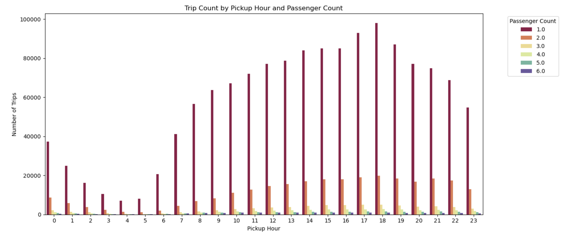

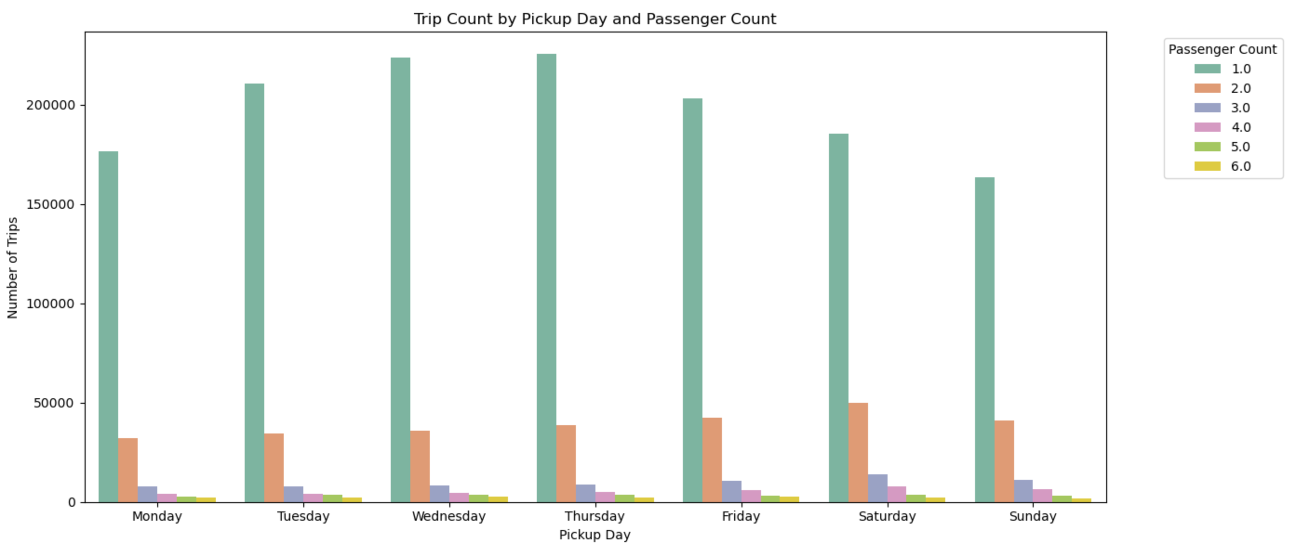

Analysis of Passenger count across Hour and Day

1. Solo travellers are way higher that any other category.

2. The trend of decreasing trip count with increasing passenger count holds true for every day and hour. 2-passenger trips (orange bars) are consistently the second most frequent.

* + 1. **Analyse the variation of passenger counts across zones**

Plotting top 20 zones 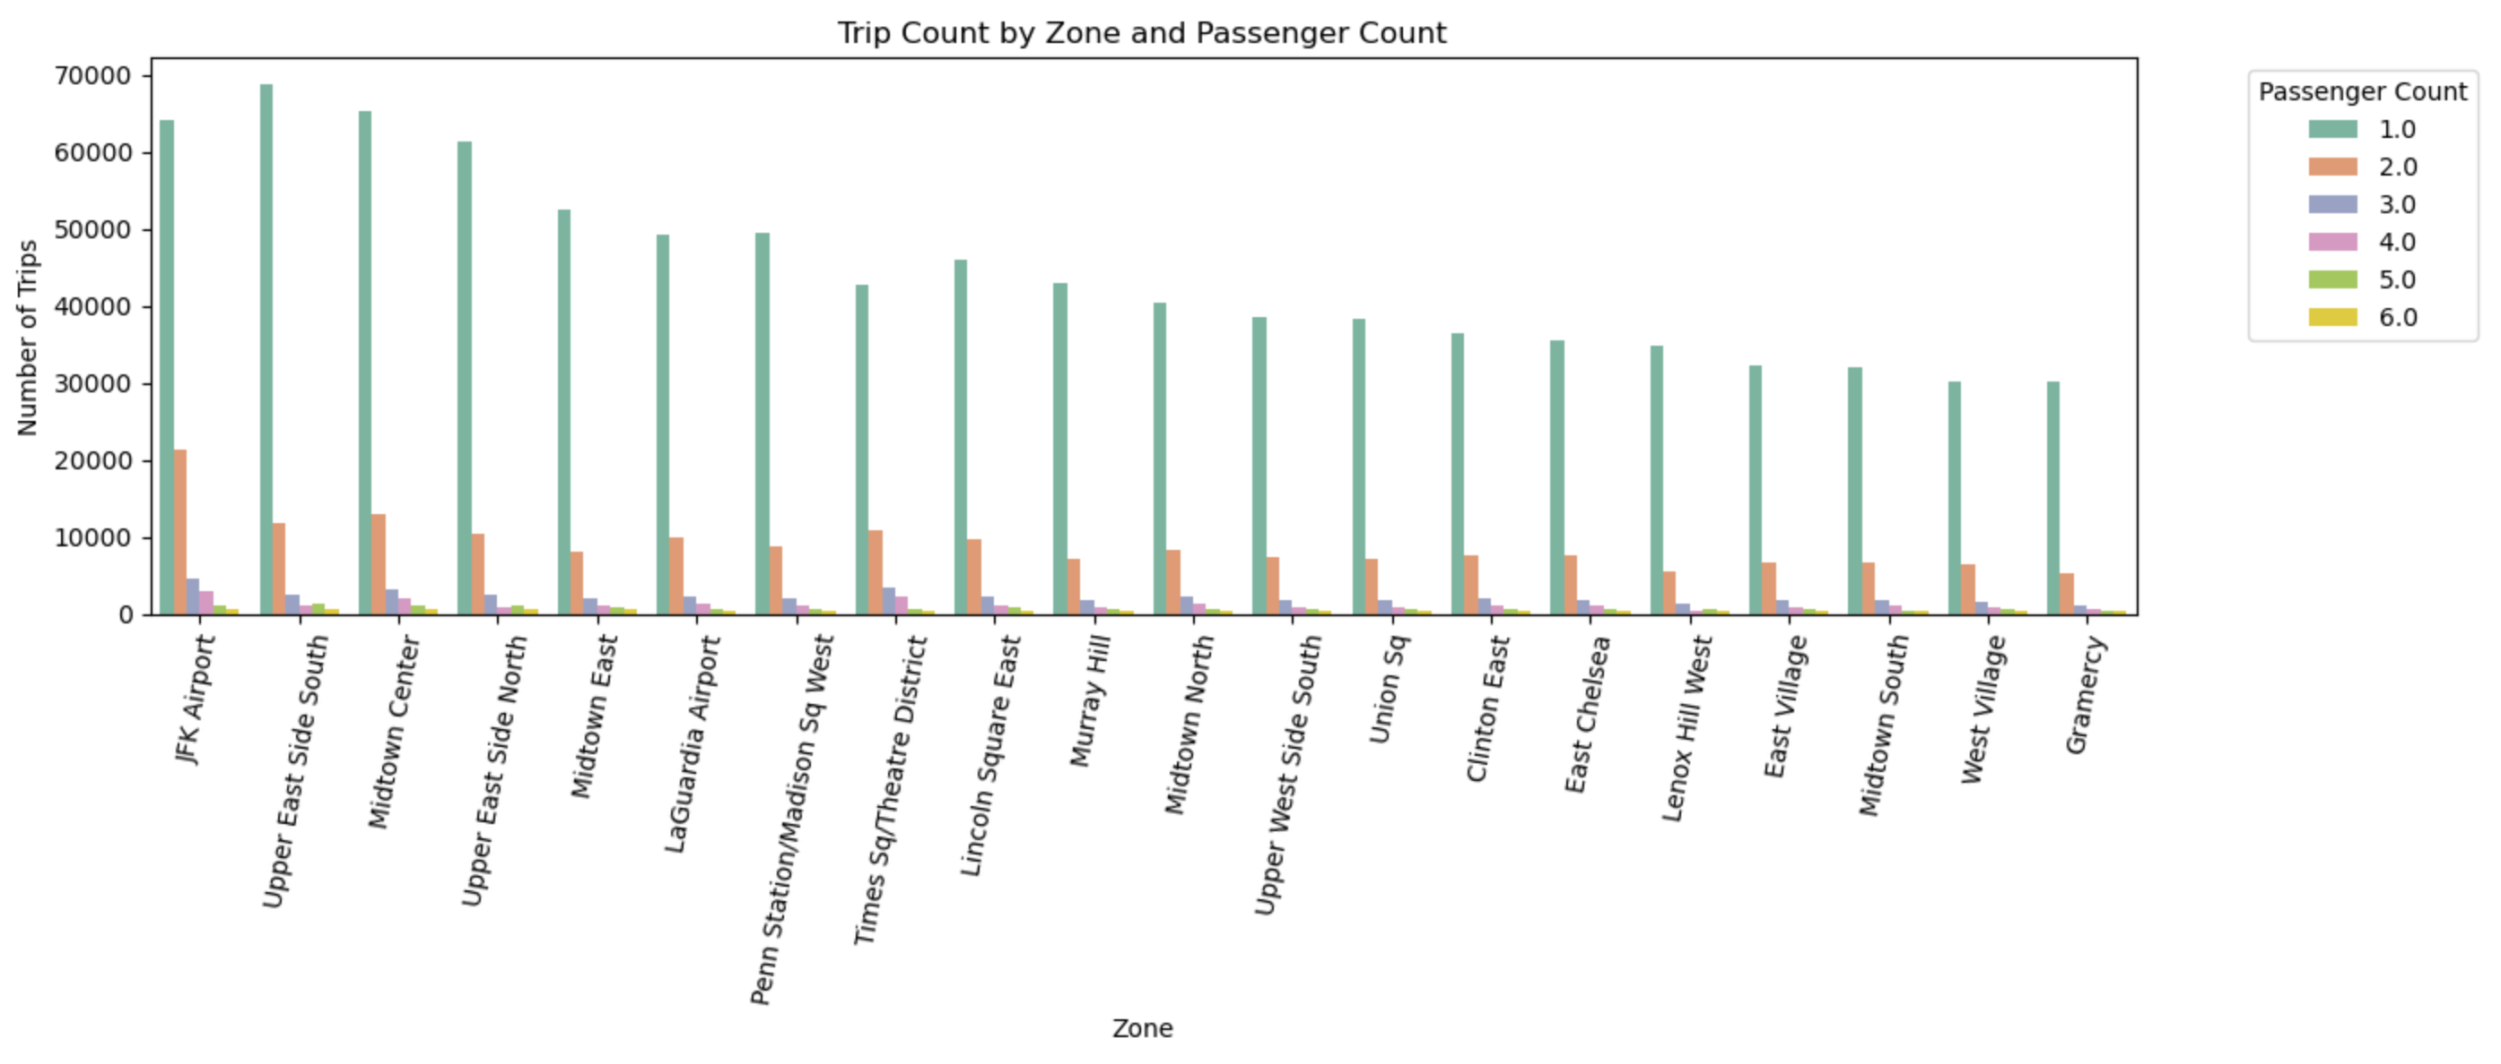

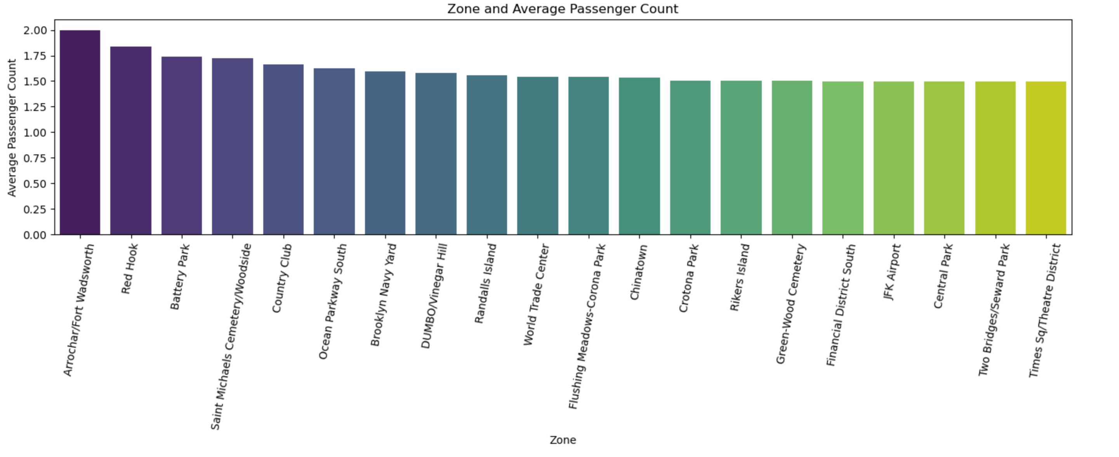Analyse Average Passenger Count across Zones

1. Most of the top 20 zones have average passenger count around 1.5

2. Fort Wadsworth and Red Hook have avg higher passenger count around 2.

* + 1. **Analyse the pickup/dropoff zones or times when extra charges are applied more frequently.**

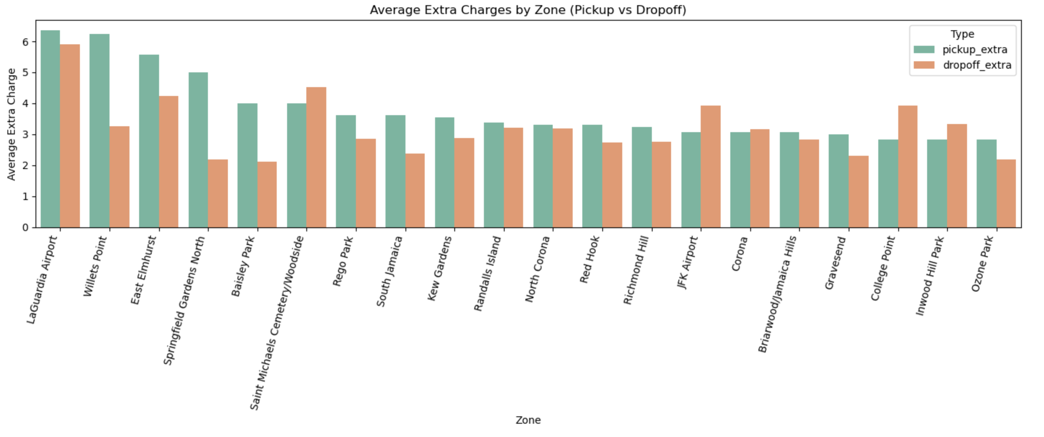

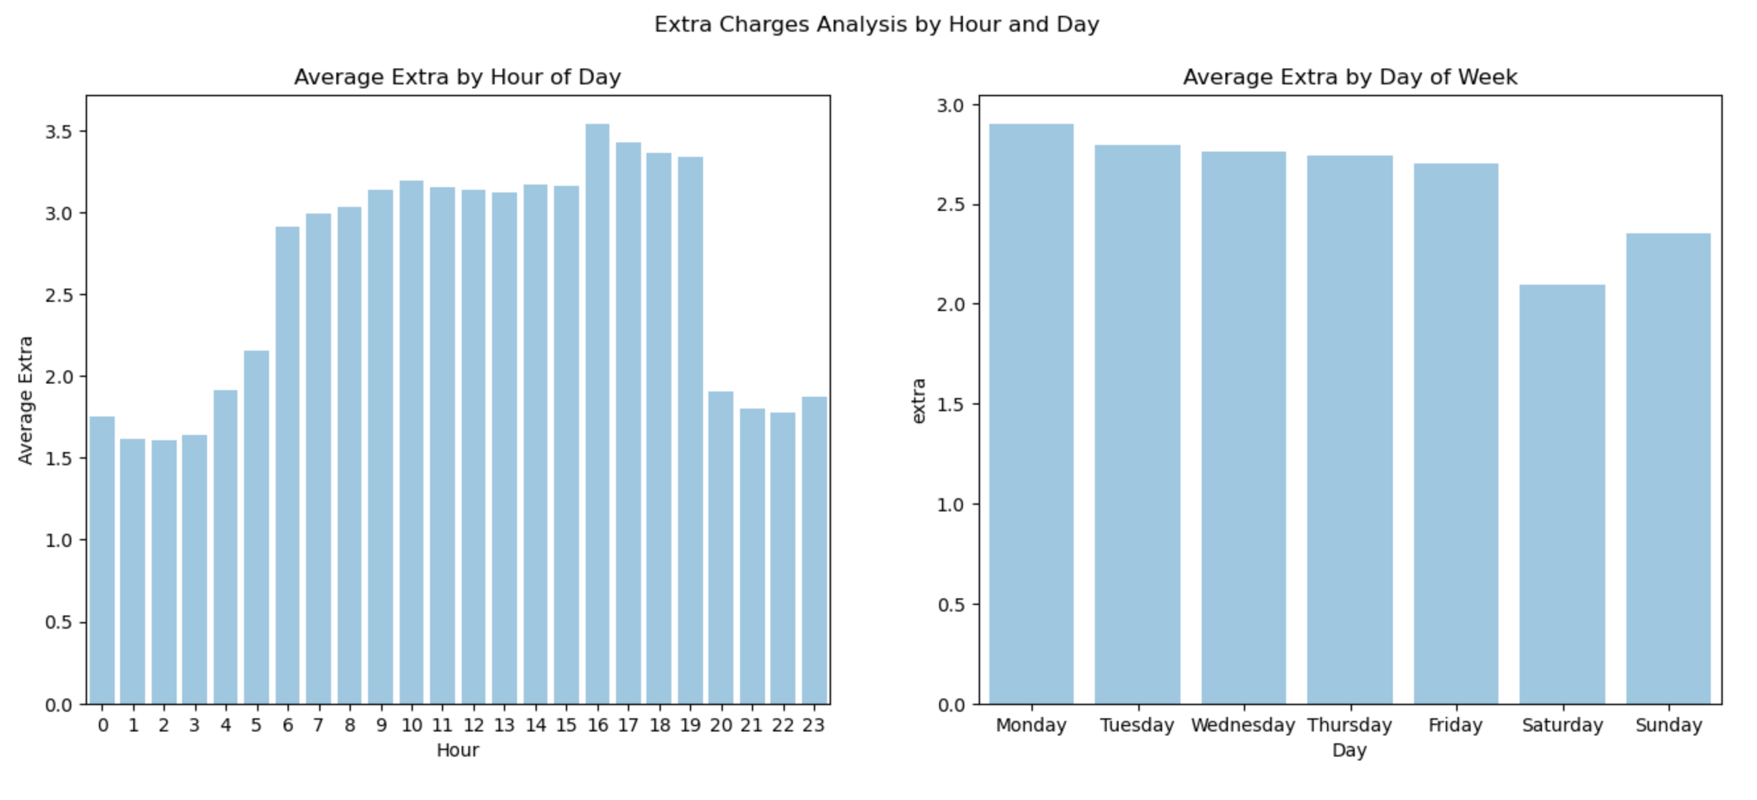

Analysis for Extra charges

1. Generally avg extra charges are highest when pickup is at LaGuardia Airport followed by Willets Point.

2. At JFK Airport avg extra charges during drop is higher.

3. Avg Extra charges are quite high during the weekday.

4. During the day 4pm - 7pm avg extra charges are quite high and during the day they are consistent at $3

5. During night time 8pm - 4am, avg Extra charges are way low at $1.5

## Conclusions

### Final Insights and Recommendations

* + 1. **Recommendations to optimize routing and dispatching based on demand patterns and operational inefficiencies.**

1. Align Driver Availability with Demand Spikes:

* Morning Peak (6–9 AM) and Evening Peak (3–7 PM) show consistently high demand.
* Assign more drivers during these windows to reduce customer wait time. This will help in good customer experience and increased revenue.

2. Reduce Inefficiencies During Lean Hours (2–5 AM):

* Lean hours see significantly fewer trips.
* Reduce fleet volume or assign drivers to standby near known hotspots (e.g., airports or night party zones).

3. Minimize Slow Routes with Historical Data:

* Analyze slowest routes per hour
* Avoid dispatching drivers through congested zones

4. Route Optimization:

* Integrate route suggestion tools in dispatch systems that dynamically account for speed trends by time of day.
* Flag zones with average speeds < 0.2 mph during dispatch to minimize inefficiencies.
  + 1. **Suggestions on strategically positioning cabs across different zones to make best use of insights uncovered by analysing trip trends across time, days and months.**

1. High-Demand Pickup Zones:

* Position cabs near JFK Airport, LaGuardia, Midtown, Upper East Side, Penn Station, and Times Square, especially during rush hours and late evenings (11 PM–2 AM).
* These zones consistently appear in both day and night high-demand lists.
* Incentivize drivers to position their taxis in higher zones.

2. Night-Time Strategy (11 PM–5 AM):

* Zones like East Village, Clinton East, West Village show high activity at night — keep a night-shift fleet allocated here.
* These trips are often shorter but may include higher tips (from your tip percent data).
* Incentivize drivers for night time trips on these zones.

3. Seasonality Positioning:

* During Spring (Mar-May) and October (Fall), demand rises — increase cab availability near tourist hubs and central Manhattan.
* Consider scaling up operations in May and October to handle revenue spikes.
* Give discount coupons of limited validity of 15 days at end of rides during months June-Sep, to increase revenue.

4. Weekend Planning:

* While overall trip volume drops, nightlife zones see increased demand during weekend late nights. Position cabs accordingly.

5. Low-Demand Zones:

* Minimize idle cab presence in zones with consistently low trip counts.
* Give offers to customers to increase customer footprint.
  + 1. **Propose data-driven adjustments to the pricing strategy to maximize revenue while maintaining competitive rates with other vendors.**

1. Adjust Fare Per Mile Dynamically:

* Data shows high average fare per mile during 4–5 AM and on Sundays.
* Implement a dynamic pricing model.

2. Leverage Tip Behavior in Pricing:

* Passengers tend to tip more for short rides and during 4 PM–3 AM.
* Introduce a “convenience fee” during high-tip hours or offer premium short-trip service tiers.

3. Promote Vendor Differentiation:

* Vendor 2 (VeriFone Inc.) fares higher on short trips; consider standardizing per-mile charges to reduce discrepancies.
* Introduce loyalty programs or discounts during off-peak hours to retain customers.

4. Optimize Pricing for Underperforming Months (e.g., Feb, Aug):

* Use discounts coupons with short validity or offers to stimulate usage.
* Consider fare waivers during low-demand hours to encourage ridership.

1. Encourage card payments with incentives, as they result in higher tips.

* Partner with Credit card providers for exclusive rates and facilities.
* Offer discount on fare amount if payment is by credit card.